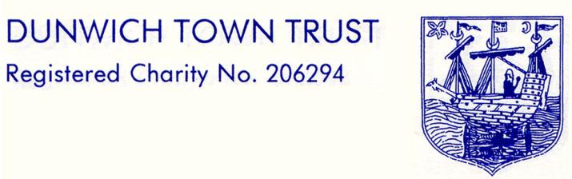

MINUTES of the MEETING HELD ON
MONDAY 9th MAY 2016 AT 6.00PM
IN THE READING ROOM, ST JAMES STREET

- Welcome and Apologies
Present: Mrs Angela Abell (AA) Chairman
Crispin Clay (CC) Treasurer
Mr Keith Maunder (KM)
Miss Nick Mayo (NM)
Ms Gussie Andersen (GA)
Mrs Val Bethell (VB)
Mark Whitby (MW)

There was one apology, Dr Dennis Cox (DC)

In attendance: Mr John Lavery (Clerk - JL)

The meeting was declared quorate.

- Minutes of the Meeting of 14th March 2016

The minutes were accepted as a true record and were signed by the Chairman.

- Matters Arising
Item 3: The King John Charter leaflet had now been placed on sale in the Museum.
England Coast path: The Chairman had received the site visit record of the proposed
Walberswick to Dunwich section. The Chairman had expressed the Trustees’ preference for
the coastal path to follow the existing Suffolk Coastal Path rather than along the shingle bank
which was an area of ecological sensitivity and was difficult to walk.
Duncan’s Field conservation area – this was still in the hands of the Land Registry which
apparently had many months of backlog.

Item 10: The Open meeting at the end of the Annual Parish Meeting had worked well and that pattern may be repeated next year. Thanks were offered to CC for giving a presentation of the financial situation. The meeting was asked for proposals about the use of the plot to the west of the Town Houses; there was general support for the idea of planting a small orchard on this site, no other suggestions were received.
A.P. JL would contact Genevieve Broad of the Orchard Network’s Suffolk Traditional Orchard Group for advice.

4. Clerk and Chairman's Report
We had received the final figures from the Traffic Survey. For the 12 months from 1st April 2015, 88,340 vehicles, equating to an estimated 202,396 visitors, had come to the car park.
Trustees were asked to consider a response to Ian Smalley who wanted to use his metal detector around the base of the veteran oak tree in Gallows Field. He had provided information about his experience, insurance and that he would surrender any findings to the Trust. Permission was granted by Trustees. He would be advised to take a copy of the e-mail granting permission with him. A Trustee might accompany Ian on his visit.
A.P. AA would e-mail Ian with permission.
General support was expressed at the Parish Meeting for some restoration of the village pump even if this was only cosmetic ( the owner of the pump had not attended the PM) . George Monger (a conservator and restorer) had been contacted and would be coming to the village on the 21st/22nd May. Funding for similar projects had been obtained from The Ironmongers’ Company. Essex & Suffolk Water might also be interested in funding.
A.P. JL would contact Elizabeth Martin, Assistant Design & Conservation Officer at SCDC to enquire about appropriate craftsmen and sources of funding.

5. Financial Report
CC reported on the financial position as laid out in the Bookkeeper’s report and accounts. CC commented on the accuracy of NK’s forecasting. It was noted that DTT had received the final money from the AAF grant for Gallows Field. Trustees were reminded that Nicholas Reid of CCLA had been invited to the next meeting.
The property revaluation report had been received from Clarke & Simpson.
C & S had also recommended that the insurance value of the old mortuary should be increased to cover the cost of its replacement.
A.P. JL would contact our Insurers and arrange for the cover to be amended as appropriate.

6. Governance
Work had continued on the registration of DTT properties and their valuations had been sent to Nicholsons.

7. Grants
Confidential minutes only.

8. Housing
Confidential minutes only.
9. Report from RR&M Rep Trustees
VB initiated a discussion about Conflicts of Interest and of Loyalties which was pertinent to her role as DTT representative trustee of the Reading Room and Museum Charity. NM would review our Conflict of Interest Policy before the next meeting.

10. AOB
The Chairman had noticed that the paling fence on the beach had partially collapsed where one of the posts had rotted, and several of the pales were missing. The Chairman suggested asking Fran Cousins, Conservation Works Ltd, to quote for repairing the fence, which was agreed.
A.P. AA to arrange.
The meeting ended at 8-50pm

Date of next meeting: 11th July 2016.

Signed: ……………………………….. Dated: …………………

